Klamath Pulmonary & Critical Care Medicine
Klamath Sleep Medicine Center
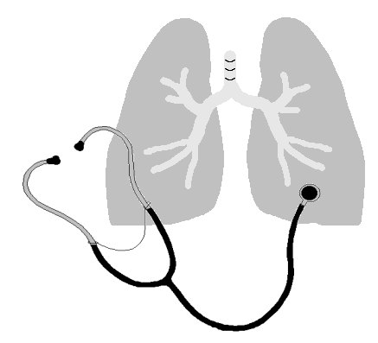

David Panossian, M.D., P.C., DABSM
2614 Almond Street, Klamath Falls, Oregon 97601
(541) 885-2201, FAX (541) 883-1400

Web Portal Consent

Our secure patient portal enables you to view your health records and summaries of your previous office visit(s). If you are interested in taking advantage of this way of managing your health care, please provide us with your email address and signature of consent below.

We will set you up on the portal with a user name and password and mail that information to you along with the web address (also provided below). Please be sure to enter the address exactly as it is shown as this is a secure web site and will need to start with https:// as indicated. The password may be changed at your convenience on the portal.

If you have any questions please do not hesitate to ask.

Thank you for the privilege of providing your health care at Klamath Pulmonary and Sleep Medicine Center.

Patient Name: ________________________________________________________________________

Email address: ________________________________________________________________________

Signature: ________________________________________ Date: ________________________

Web Portal address:

https://mycw67.ecwcloud.com/portal8773/jsp/100mp/login.jsp

